PDO process can connect to any db type (MySQL, Oracle). To activate it, go to the php.ini file and put this line in (or take off the semi colon in front)

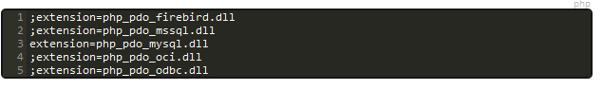

When declaring your $db in your script, use this formulation instead to catch errors and display the log if needed:

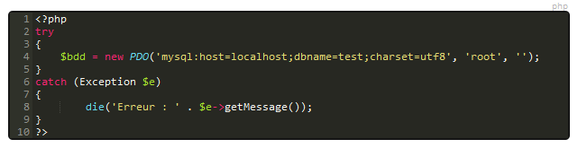

This is how we make a request:

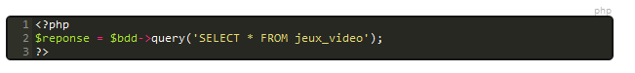

Ande return the object of results:

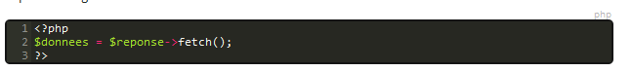

We want to reorganize it into an array, so we use a while loop, which will send each line one after another to $donnees

http://i.gyazo.com/493e8f0eafbf34bf143bdc8b4c7b7ebd.png

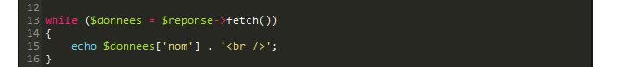

http://i.gyazo.com/bfbac501757d8653c6d5fe1db5b17933.png

Inserting values

To insert values, we use the INSERT command, and from there we specify the columns names and in parallel a the values for these we wish to insert.

$db->exec(“INSERT INTO table(col1,col2,col3) VALUES(val1,val2,val3)”);

For a more organized approach, we prepare a request, and insert an array:

$db->prepare(“ISNERT INTO table(col1, col2, col3) VALUES (:val1, val2, :val3)”);

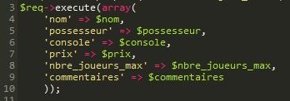

http://i.gyazo.com/4c6e0867bdd7e6ae3c254c03bd71fe46.png

**Fonctions en SQL**

http://i.gyazo.com/44408dbb2fab91fc27085843a015b454.png

Recupere l’information et la met en majuscules and puts it in the column ‘nom_maj’, even if the column was not originally called that. Same goes for LOWER, which returns the names all in small letters.

http://i.gyazo.com/9c71a367aec960c741743bc5de64fee9.png

This returns the lengths of the strings in the column jeux_video

http://i.gyazo.com/619c0acaf322f4b83cda8d7e54ca1d72.png

If you wanna round up a decimal to 2 digits, you use round(data, 2)

http://i.gyazo.com/cb0529d873243347e955e38b0b0c2cef.png

This computes the mean of a column of integers

http://i.gyazo.com/7aa1a1c844de7f94396b9243aa359da4.png

Computes the sum of all the values in the column

http://i.gyazo.com/1f89d7f835091f70ad2597c7156f7b8b.png

Return the max value of a column of integers

http://i.gyazo.com/d142897a0d5b6ca2784b24dca67b379f.png

Returns the number of entries in a table

http://i.gyazo.com/984eb7d4bbaf4b07e08f1856753eb615.png

You can filter the count by specifying which column should be the filter and count only the distinct values

http://i.gyazo.com/322b08c6472b98e6f9b75b3bd88d9024.png

Now() returns the actual date in timestamp format

http://i.gyazo.com/70e2373b1bf5e482e8ee03855f23fe12.png

You wanna extract just a part of the date? the day, the month? Use the day() month() functions when selecting your timestamp!

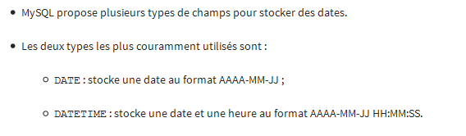

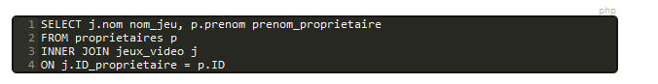

You can only use the first letter of a table on long queries

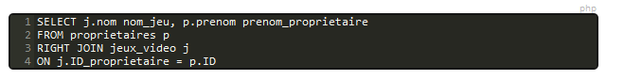

Sometimes, you wanna use a one to many comparison but only take the books of an author in particular you know from before the query, then use RIGHT JOIN. Even if there is no correspondence between left and right table, values will be returned, whereas with inner join, values are returned only if the values in both tables have correspondence.